THE GEAUGA METROPOLITAN
HOUSING AUTHORITY

JEANNE BOSTWICK MEMORIAL SCHOLARSHIP

2024  Scholarship  Application | 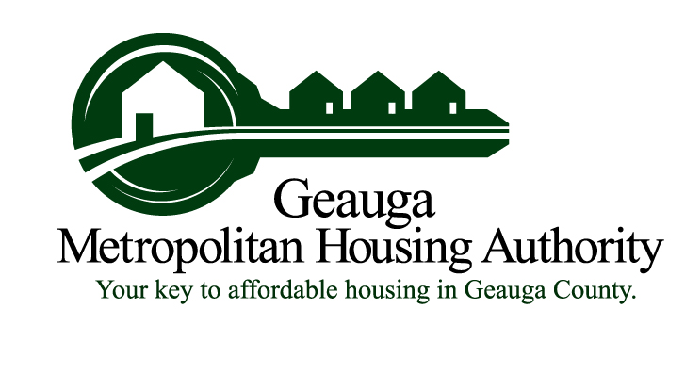
Purpose:
It is the intent of the Geauga Metropolitan Housing Authority (GMHA) to establish a scholarship for the participants of GMHA’s Public Housing and Housing Choice Voucher Programs, as well as those members of the community who meet the income requirements of HUD’s Section 3 program. Recognizing that the cost of higher education is oftentimes prohibitive and can lead to long-term financial obligations, the GMHA wishes to assist deserving students and provide them with the opportunity to achieve their aspirations and educational goals. GMHA plans to award two $1,000 scholarships.
History:
The Geauga Metropolitan Housing Authority (GMHA) was created in 1969 by what was then known as the State of Ohio Board of Housing. Consequently, GMHA’s Charter was formed with subsequent powers being derived directly from the Ohio Revised Code. Even with the Charter completed, it wasn’t until 1981 that the agency received its first grant funding for 106 housing units from the U.S. Department of HUD. Over the years, GMHA has expanded to a total of 243 public housing units within Geauga County where it maintains 100% occupancy. Additionally, GMHA maintains an extensive waiting list of applicants.

GMHA also administers Section 8 Housing Choice Voucher and Mainstream Voucher rental assistance programs. Through these programs, GMHA can assist up to 171 qualified low-income families with traditional vouchers and an additional 13 families under Mainstream with their rent and utility costs. Housing is obtained through privately owned properties. GMHA maintains a separate waiting list of applicants seeking the Section 8 HCV and Mainstream program assistance.
Who:
Scholarship recipients shall be selected on the basis of:
First priority will be given to GMHA’s Public Housing and Housing Choice Voucher/Mainstream participants in good standing with GMHA’s Family Self Sufficiency Program (FSS), followed by other members of GMHA’s Public Housing and HCV/Mainstream programs, concluding with other residents of Geauga County who meet the current Section 3 income guidelines – see attachment. Student(s) must be a resident of Geauga County, attending an accredited college, recognized trade/vocational school, or be a graduating senior. A minimum grade point average of 2.5 is required. Family member of GMHA employees or contractors are not eligible. Previous winners will only be considered if there are an insufficient number of new applicants.
To Apply:
Student(s) must complete an application (available through the GMHA’s main office or website) and include a 350 to 500-word essay (maximum), typewritten in English, describing how receiving a scholarship will impact their goals/career, their educational goals, as well as any participation in volunteer and community service. Selected student(s) will be invited to attend the June meeting of the Geauga Metropolitan Housing Authority.
2024 GMHA Jeanne Bostwick Scholarship Application

NameClick here to enter text. Phone NumberClick here to enter text.
Address Click here to enter text.

CityClick here to enter text. StateClick here to enter text. Zip CodeClick here to enter text.

EmailClick here to enter text. Student’s Cell Phone #Click here to enter text.

SSN XXX-XX-Click here to enter text. Grade in School Click here to enter text. Graduation DateClick here to enter text.

What is your desired Academic Major (if any) or trade/vocation?Click here to enter text.

To which colleges or trade/vocational schools have you applied?

To which colleges or trade/vocational schools have you been accepted?

Summarize your academic achievements (i.e., scholarships, awards, etc.)
Click here to enter text.

List extracurricular school activities in which you are currently participating (i.e., clubs, teams, etc.)
Click here to enter text.

Indicate the community activities in which you are currently participating (i.e., church, community service, etc.)
Click here to enter text.

Indicate extracurricular and community activities in which you have participated in the past.
Click here to enter text.

List any hobbies or special interests.
Click here to enter text.

Indicate any jobs which you are holding or have held in the past.
Click here to enter text.

Thank you and good luck.

In addition to the above information, you must provide the housing authority Executive Director with the items indicated on the “Requirement Checklist” in the scholarship application packet.

Incomplete applications will not be considered.
Requirement Checklist

Submit the following documents to the Executive Director of GMHA.
All documents must be typewritten in English. Please do not fold or staple documents.

☐ 1. Application: The application can be found at our office or on GMHA’s website at www.geaugamha.org. On the homepage, click the “GMHA’s Jeanne Bostwick Scholarship Application.” You may download and complete the form, save it to your computer and print a copy. Include this printed application in the packet of materials that you submit to the Executive Director.

☐ 2. Verifications: Official school transcript indicating your grade point average.

☐ 3. Letter of Recommendation: You must submit at least one personal letter of recommendation from a teacher, guidance counselor, pastor, or other NON-Family professional.

☐ 4. Essay: You must submit a typewritten essay in English describing how receiving a scholarship will impact your goals/career, your educational goals, as well as any participation in volunteer and community service. (350–500 words)
Certification: (Must be signed by student and Executive Director)

EXECUTIVE DIRECTOR: Please verify all information is provided. Incomplete applications will be rejected.

I certify that all information is true and correct to the best of my knowledge. I further certify the application is complete and contains all items from the “Requirement Checklist.”

Student’s Signature Executive Director’s Signature

Date Date

Deadline – All application materials must be received by GMHA no later than noon, Friday, June 7, 2024, NO EXCEPTIONS! Applications may be mailed to or dropped off at 385 Center Street - Office, Chardon, Ohio, 44024. No Faxes will be accepted.

Jeanne Bostwick
December 10, 1922 - April 26, 2008
Born December 10, 1922, Jeanne Bostwick was a lifetime resident of Chardon, Ohio. She came from a close-knit family being the second youngest of five sisters. When she was just 34 years old, she became a paraplegic as a result of an automobile accident. This challenge she met with a spirited, head-on attitude. She did not let any dust gather under her wheels. After her husband's passing 4 years later, she raised their three children practically by herself. During her lifetime she owned an answering service, became a realtor, an antique appraiser, and owned and operated Bostwick Antiques for over 50 years out of her home on South Street. Her commitment to her community was demonstrated by her volunteering on the GMHA board and serving as Board Chair from March 2005 thru November 2007. Jeanne is well known for her passion of golf, bridge and other card games, antiques, and a great sense of humor. Her home was always filled with family and friends. All who knew her admired her for her honesty and fairness.

2023 Section 3 Income Limits
As of April 1, 2023 (2024 Limits have not been released)

Number of Persons in Family | Gross Annual  Income Limit
1 | 50,650
2 | 57,850
3 | 65,100
4 | 72,300
5 | 78,100
6 | 83,900
7 | 89,700
8 | 95,450

